Task 14: **Public IP / Elastic IP**

1. Instance Created with the IP 18.138.58.113 & Stopped

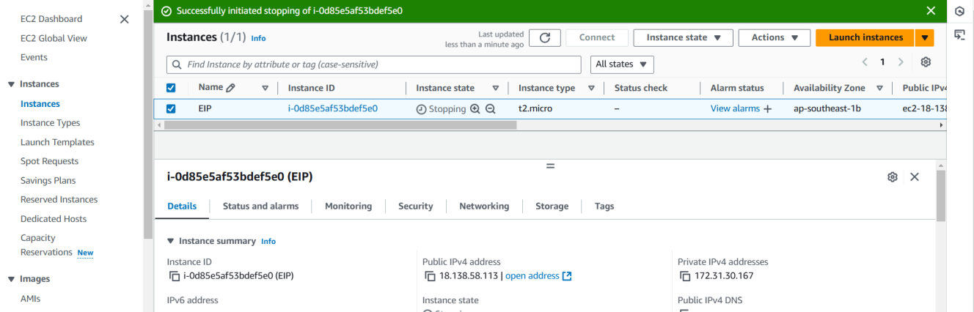

1. The Public IP disabled

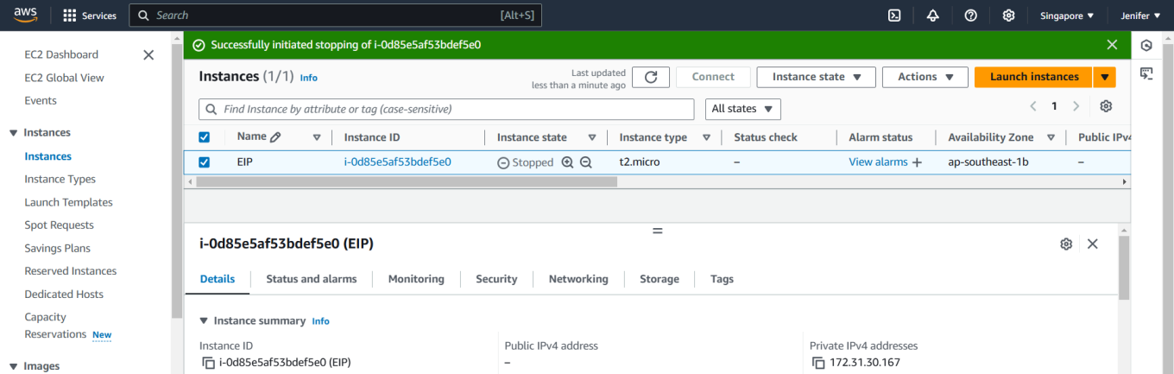

1. Instance Started with the New Public IP 13.215.140.59

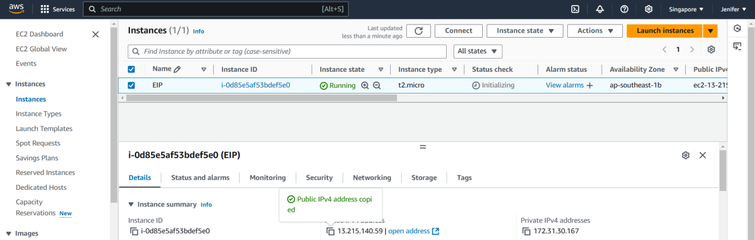

1. Elastic IP Address allocated

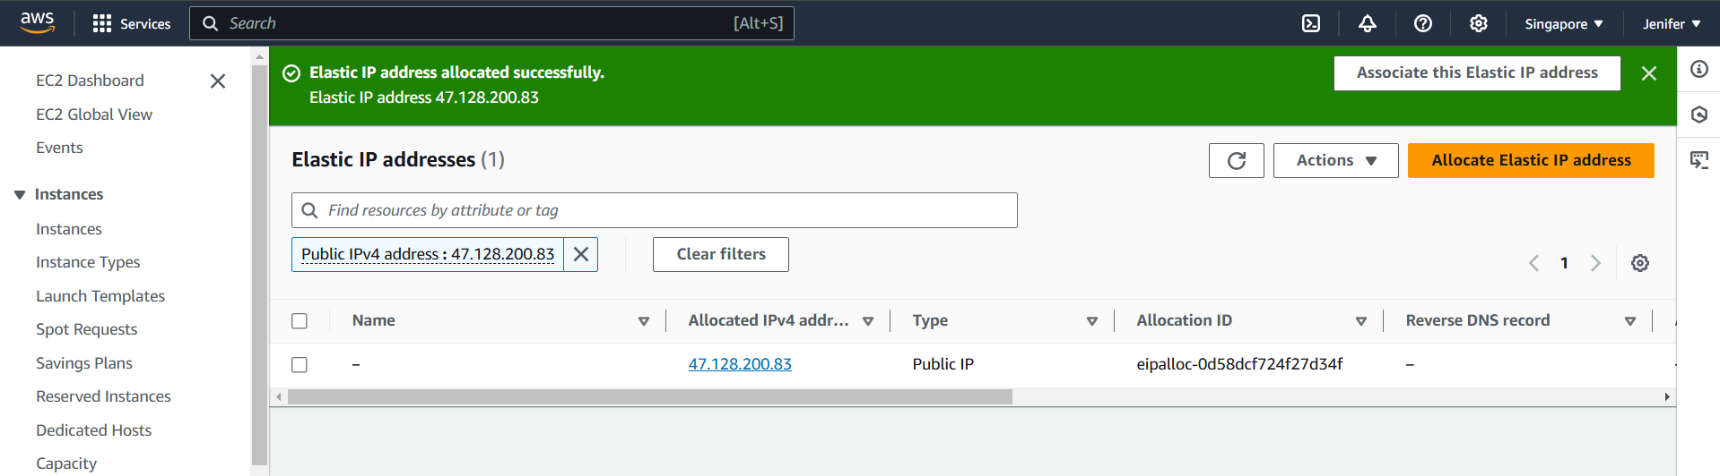

1. EIP associated successfully to the Instance:

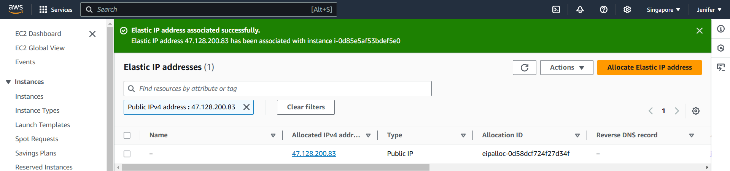

1. EIP reflected in the EC2 console

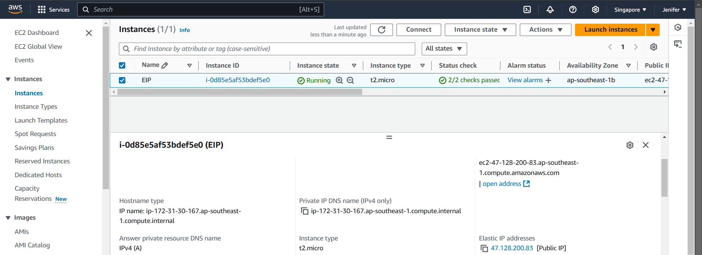

1. Jenkins installed and got ready to start

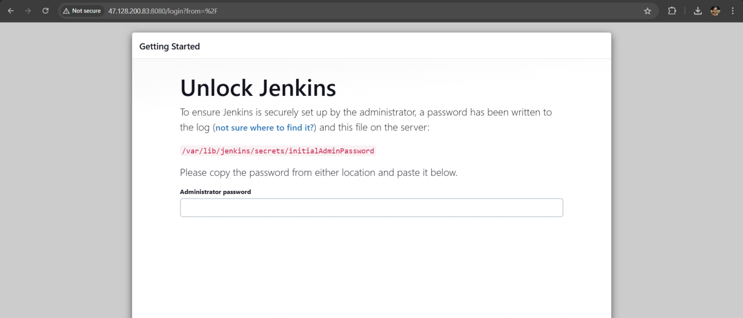

1. EIP disassociated and released from the instance

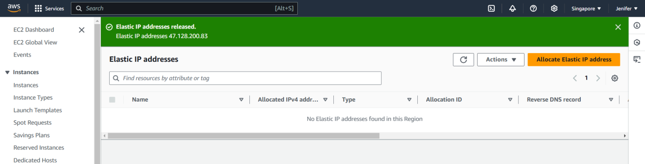

1. After EIP got released, the new public IP Allocated by AWS as usual

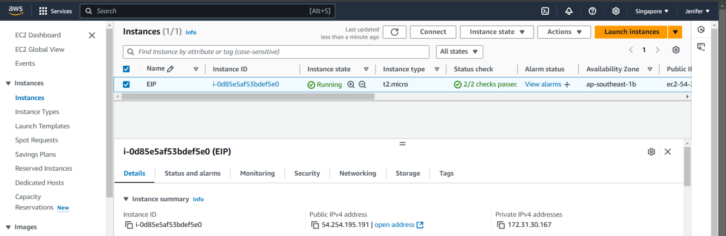

**Public IP**

A public IP address changes when the instance get stopped

**Elastic IP**

A static public IP address that’s associated with an AWS account. EIPs are allocated to an account and remain the same, even if the instance they’re associated with is stopped